E-Commerce Sales Data Analysis Project Report
1. Executive Summary & Project Overview
This project presents an end-to-end data analytics study of an e-commerce platform’s sales performance using transactional records spanning from January 1, 2023, through June 30, 2025. The objective is to convert raw sales data into actionable business intelligence by executing data cleaning and pre-processing, exploratory data analysis (EDA), and structured SQL querying.
The dataset comprises 1,200 unique order transactions across 1,189 individual customers, yielding a total gross revenue of $1,264,761.96 with an average order value (AOV) of $1,053.97.
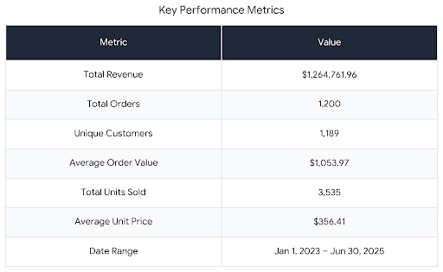
2. Tools & Dataset Architecture
Core Tech Stack
Python (Pandas, NumPy): Used for data cleaning, structural validation, and descriptive statistical analysis.
- SQL (MySQL / PostgreSQL dialect): Used for data extraction, aggregations, customer behaviour filtering, and key metric queries.
- Data Visualization & Analytics: Excel, Pandas, and SQL querying modules.

• Dataset Schema
The raw dataset contains 14 attributes across 1,200 rows:
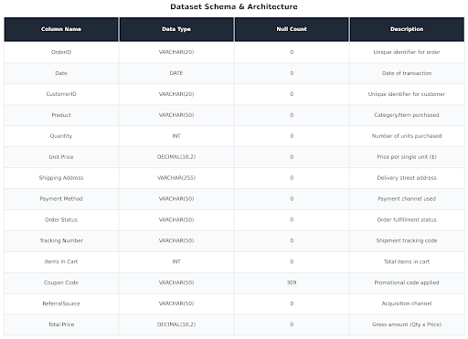
3. Data Cleaning & Preparation
The raw dataset underwent structured pre-processing to ensure data hygiene prior to SQL execution and analysis.
• Cleaning Steps & Transformation Logic
1. Header Normalization: Trailing whitespace was removed from column headers (e.g., Unit Price - Unit Price, Shipping Address - Shipping Address).
2. Missing Value Treatment:
Coupon Code contained 309 missing values (25.75% messiness). Missing entries were imputed with the explicit label ‘No Coupon’ to retain order records while differentiating non-discounted sales.
All remaining 13 features had zero null values.
3. Data Type Casts & Validation:
- Date was parsed as standard YYYY-MM-DD date time.
- Quantity and Items In Cart were verified as integer types.
- Unit Price and Total Price were confirmed as positive float values.
4. Duplicate Verification: Checked across Order ID records; zero duplicate transactions were detected.
5. Calculated Column Audit: Verified that Total Price = Quantity times {Unit Price} across all 1,200 rows.

4. Exploratory Data Analysis (EDA)
• Product Performance Analysis
The platform offers 7 distinct product categories. Revenue distribution across categories remains remarkably uniform, ranging between 12% and 15% per product.
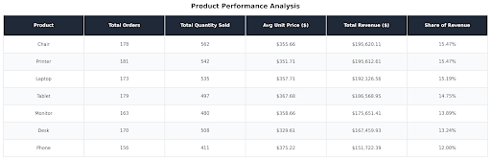
• Fulfilment & Order Status Analysis
Order completion analysis reveals significant operational bottlenecks. Only 38.8% of orders are currently fulfilled (Delivered + Shipped).
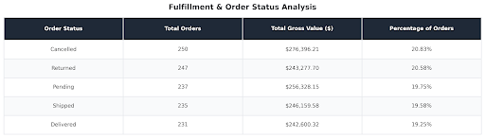

Critical Finding: High cancellation (20.83%) and return rates (20.58%) represent a total potential revenue loss of $519,673.91 (41.41% of total gross order value).

• Marketing Acquisition Channel Breakdown
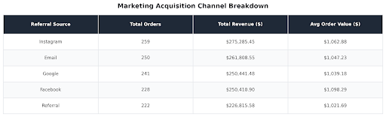
Instagram and Email generate the highest order volume and gross revenue.

• Payment Method Performance
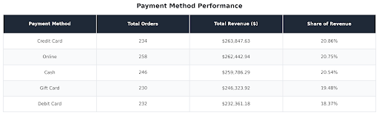
Payment channel utilization is evenly split across five primary payment options.

5. SQL Queries & Insights Extraction
Below are the SQL scripts created to model, query, and extract insights from the e-commerce sales database.

Query 1: Table Creation Schema

Query 2: Executive Sales Performance Summary
Extracts overall platform performance indicators.

Output Insight: The store generated $1,264,761.96 from 1,200 transactions, averaging $1,053.97 per order.

Query 3: Product Category Ranking by Revenue & Quantity
Identifies best-selling and highest-grossing products.

Output Insight: Chair ($195,620.11) and Printer ($195,612.61) lead revenue generation, while Chair also ranks highest in units sold (562 units).

Query 4: Analysis of Lost Revenue (Returns & Cancellations)
Calculates revenue tied up in fulfilled vs. Unfulfilled or lost orders.

Output Insight: Cancellations ($276,396.21) and Returns ($243,277.70) combined constitute 41.41% of total order counts, highlighting a key area for operational improvement.

Query 5: Referral Channel Revenue Efficiency
Evaluates customer acquisition source profitability.

Output Insight: Instagram generated the highest total revenue ($275,285.45 across 259

orders), while Facebook generated the highest average order value ($1,098.29 per order).

Query 6: Promo Code Impact & Usage Distribution
Measures order volume and revenue across promotional coupon codes.

Output Insight: FREESHIP was the most popular coupon code (313 orders, $335,036.99 total revenue). Orders without coupons accounted for 309 transactions ($322,401.41).

Query 7: Yearly Revenue & Growth Trend
Aggregates annual performance metrics.

Output Insight: Full-year revenue stood at $552,643.24 in 2023 (510 orders) and $480,235.87 in 2024 (459 orders). H1 2025 recorded $231,882.85 across 231 orders.
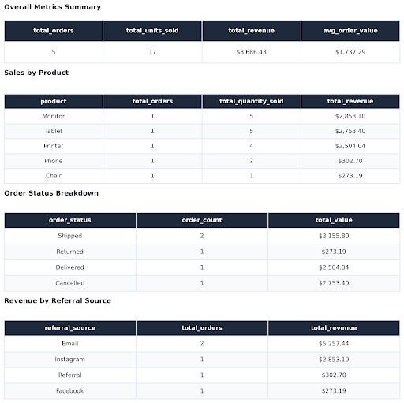
6. Key Business Insights & Recommendations
### Strategic Recommendations
1. Reduce Return & Cancellation Rates:
Problem: Over 41% of orders are lost to returns ($243k) or cancellations ($276k).
Action: Audit product descriptions, sizing charts, and quality checks for top-returned categories (Chairs, Printers, Tablets). Implement automated post-purchase confirmation messages to reduce accidental cancellations.
2. Optimize Marketing Spend by Channel:
Action: Reallocate acquisition budgets toward Instagram (highest revenue generation at $275k) and Facebook (highest average order size at $1,098.29).
3. Refine Promotional Strategy:
Action: Since FREESHIP drives the highest order conversion (313 orders), evaluate setting a minimum basket size threshold (e.g., $800) to qualify for free shipping, boosting AOV while controlling fulfilment margins.
4. Address Operational Order Delays:
Action: With 237 orders currently in Pending status, streamline warehouse dispatch workflows to shorten processing times and prevent order abandonment.

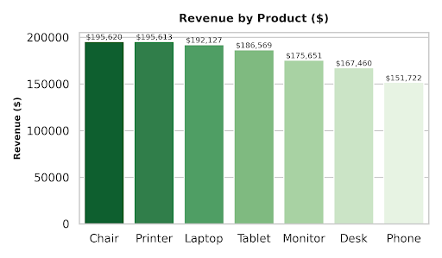
CHARTS
